Scale Free Flight Brief 37. October 2021
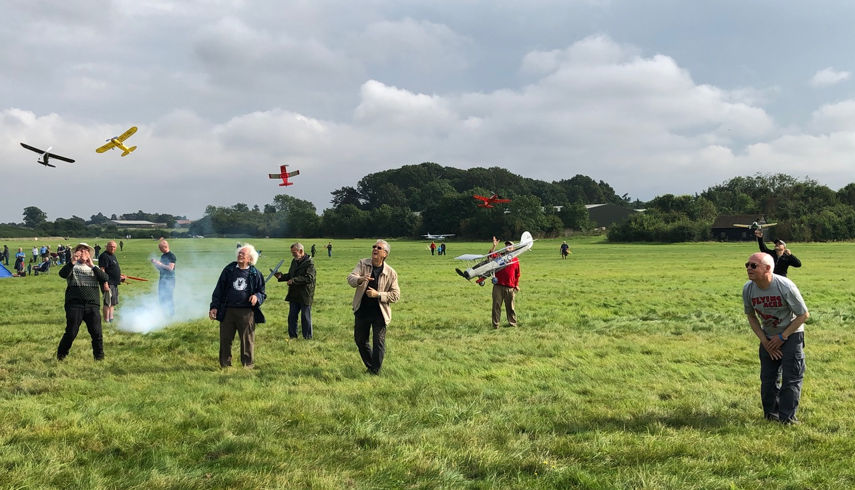
Rubber Scale Mass Launch at Old Warden in September. Pete Smart (centre) first down and Mike Smith (far left) was last down. Photo Andy Sephton.
Sunday 17th October SAM35 Octoberfest @ Buckminster
I put this down on the calendar as a Rubber Precision contest but it did not work out like that.
It rained and got quite soggy up to 1.30pm. I resisted buying anything at the Swap-meet and joined Pete Fardell with John Ashmole and the hardy SAM35 flyers.
I thought Pete had spent some money at the swap-meet but it turned out that Pete had left his stooge at home and this was a very inventive modification of his rubber band pot and a
coat hanger.
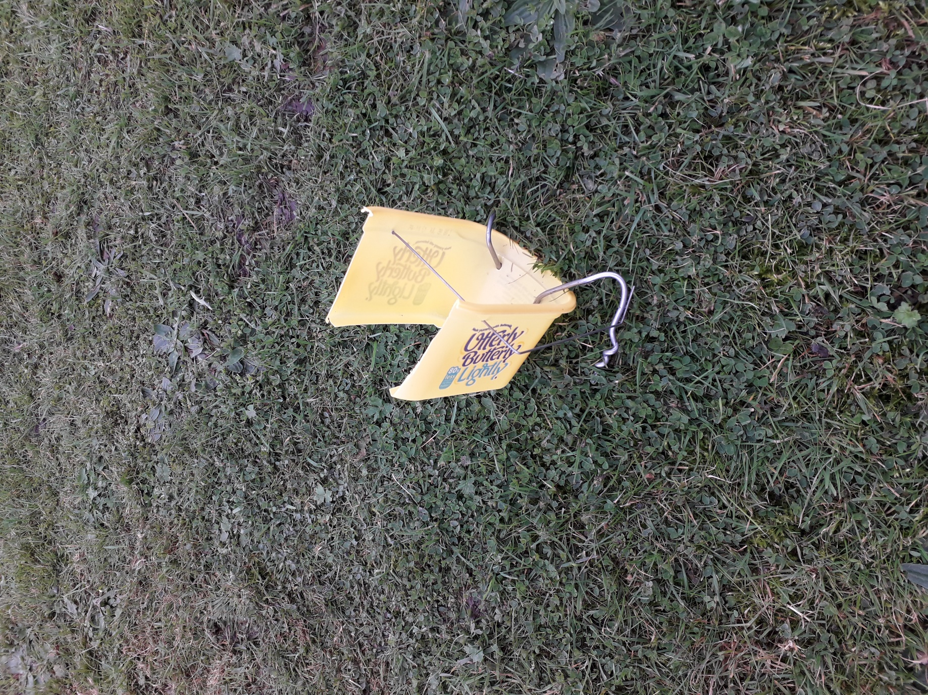
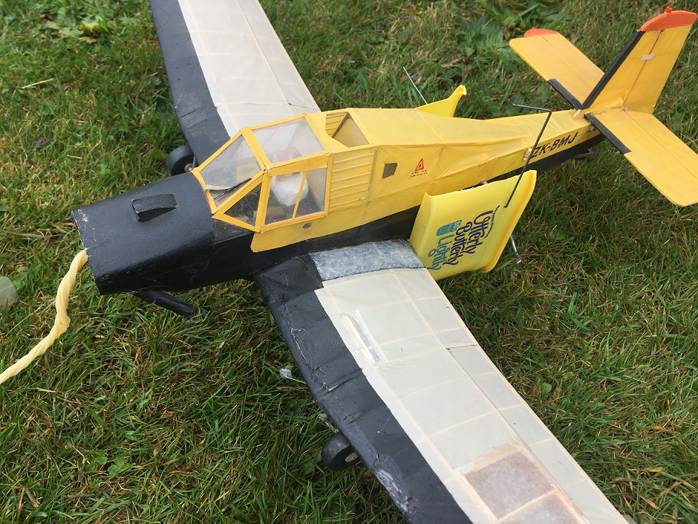
The weather slowly cleared and Pete and I signed up for the Rubber Ratio contest that John was running. We were handicapped using our scale models against the duration types but we scored some very respectable times in the conditions. Good fun all round.
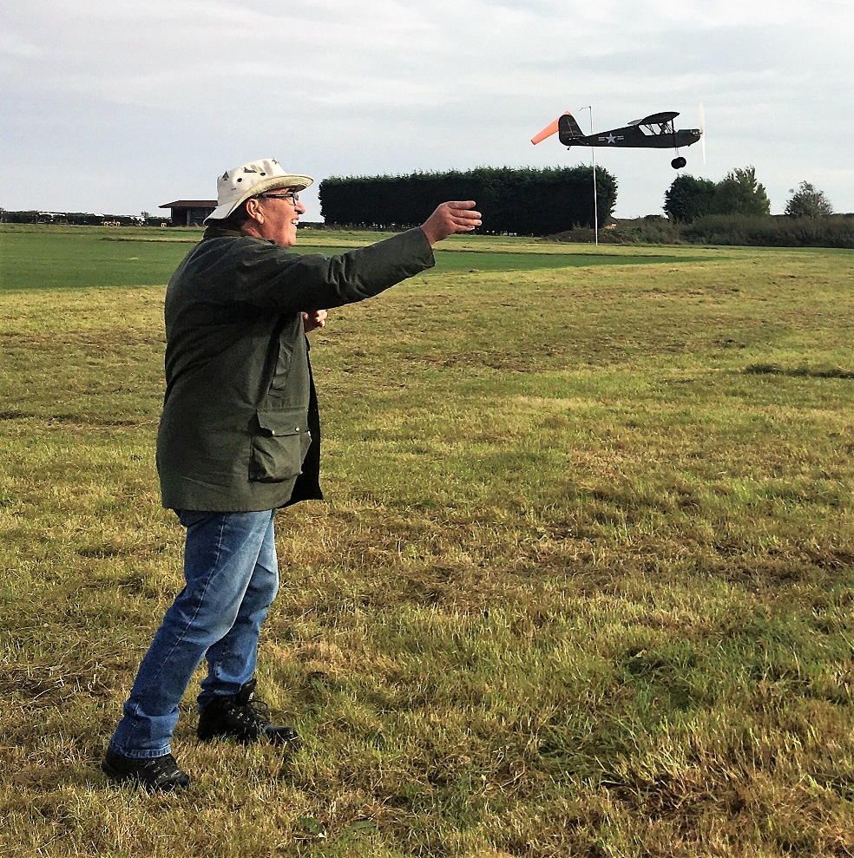
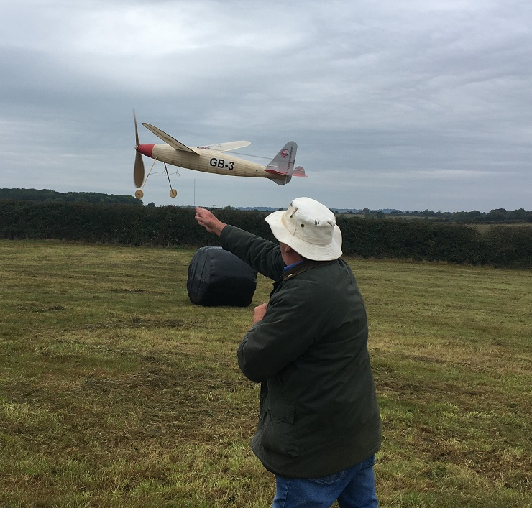
I claim editorial prerogative here as this Copland GB3 is not scale, and some certain persons were only too quick to pull my leg about it. It has a r/c rudder assist so that I do not have to walk too far to retrieve it. With 8ozs of rubber in it, it can go a loooong way!
The grass on the field had recently been cut and is contained in what resembled giant black bog rolls all over the place.
Thanks must go to John Ashmole, who organised the contest under very difficult circumstances in more ways than one.

Next Event.
The weather forecast for next weekend’s Lodge Farm does not look to good but I will send out email later this week. If all else fails we have the option, c/o Phil Ball, to attend the Midland Gala at Barkston Heath on SATURDAY 30th October.

Mike

